Question 1.

Consider the following tree
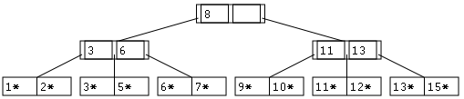
A) Suppose this is an ISAM tree. Show the tree after inserting the following elements: (16, 17, 18) and then deleting the following elements: (11, 12, 16).
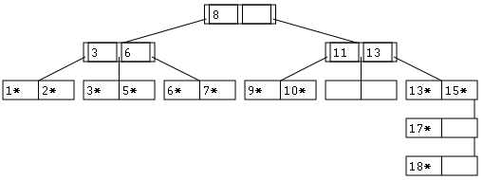
B) Suppose this is a B+ tree. Show the tree after inserting the following elements (16. 17, 18)
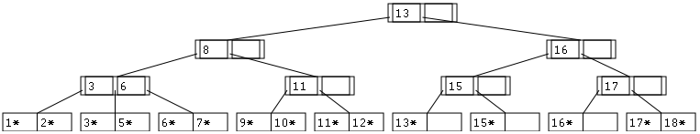
C) Now show tree from part B after deleting the following elements: (11, 12, 16). Assume the deletion algorithm tries to merge/redistribute with the right sibling if one exists.
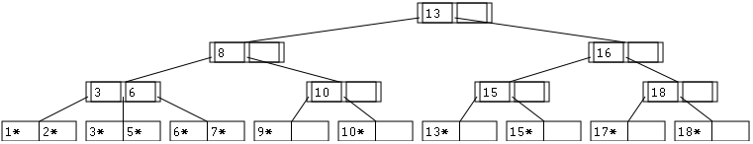
Question 2.

Suppose we are bulk-loading a B-Tree. Pages are 4096 bytes, with 88 bytes of each used for headers. A key value takes 8 bytes, and a pointer to a tree node or row takes 8 bytes.
A) What is the degree of the B-tree?
4096 – 88 = 4008 bytes available for data. 4008/8 = 501 8-byte “objects”: the tree can hold a maximum of 250 keys and 251 child pointers. The degree (or order) is the minimum allowable, which is half the capacity. 250/2 = 125.
B) Each leaf node is to be loaded to a maximum occupancy of 0.8, and there are 1,000,000 rows. How many leaf nodes will there be?
As above, a leaf node can hold up to 250 key/pointer pairs (we will have 8 bytes left over). 80% of 250 is 200. 1000000/200 = 5000 leaf nodes.
C) How high will the tree be?
In the bulk loading algorithm presented in the book, [almost] all internal nodes end up half full, so 125 keys and 126 pointers.
5000/126 = 40 nodes on the first level. These will all have 1 parent, so the height is 2. Alternately, ceil(log₁₂₆(5000)) = 2. If you assume the internal nodes are full or 80% full, you get the same answer. (Partial credit can be given for 3, since it’s a little obscure whether you should count the leaf nodes as a level.)
Question 3.

Suppose we are building a extensible hash index on a table of 1,000,000 rows. Key values are 8 bytes, a pointer to a row is 8 bytes, and a page is 4096 bytes. Each bucket needs 8 bytes at the end reserved for an overflow bucket pointer. Assume all keys are distinct.
A) What is the (lowest possible) global depth?
Bucket entries will be key/pointer pairs, so 16 bytes each. 4096-8 = 4088 bytes available. floor(4088/16) = 255 entries / bucket. 1000000/255 = at least 3922 buckets needed. Since the directory is always a power of 2 size, it will have at least 2¹² = 4096 entries, so the global depth is 12.
B) What is the average occupancy of a bucket, assuming all buckets have a local depth equal to the global depth from part (A)?
If all buckets have local depth equal to global depth, then every pointer in the directory points to a unique bucket. Thus, there are 4096 buckets. 4096 * 255 = capacity of 1044480. 1000000/1044480 ~= 95.7% occupancy.

Question 4.

Consider the Extensible Hash structure shown on page 377 (Fig 11.6).
A) Show the structure after removing the record with hash value 10.
(This changes nothing except that the 10 is gone. Bucket C is empty)
B) Show the structure from part A after adding two records with hash value 27.
(Bucket D splits. The bucket pointed to by directory entry 011 contains 19*, 27*, 27*. The (new) bucket pointed to by directory entry 111 contains 15*, 7*.)
C) Show the structure from part B after adding two records with hash value 28.
(Bucket A2 splits. This requires the directory to double to have 16 entries. 0000 to 0111 point to the same buckets that 000 to 111 did. 1000 to 1111 point to the same entries that 000 to 111 did, except that 1100 points to a new bucket “A3.” A2 now contains 4*, 20*. A3 contains 12*, 28*, 28*. The global depth is 4. Buckets A2 and A3 have depth 4. All other buckets have the same depth they did before.)
Question 5.

Draw query trees for the following relational algebra expressions based on the "movies.db" database's schema:
A. π_{first,last}(σ_{movieId=2643 ^ sex ='F'}(Customers Rentals))
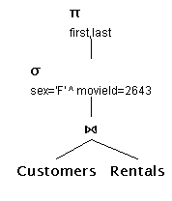

B. π_{first,last}(σ_{sex='F'}(Customers) σ_{movieId=2643}(Rentals))
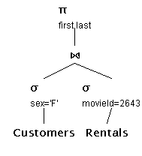

C. π_{first,last}(σ_{movieId=2643}(σ_{sex='F'}(Customers) Rentals))
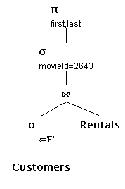

D. π_{first,last}(σ_{sex='F'}(Customers σ_{movieId=2643}(Rentals)))
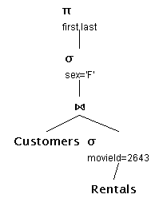
Question 6.

Use the following simple hashing scheme, key = CardNo % 4096, to build indexes for the "Rentals" and "Customers" tables of the movies.db database from problem sets #2 and #3 using SQLite and Python. Use your index to answer the following questions.
A. What is the occupancy of (number of records in) the largest, smallest, and average buckets?
 | Largest | Smallest | Average | (Total)
Customers | 150 | 83 | 117.23 | 480189
Rentals | 3979 | 1218 | 2229.55 | 9132234

B. Using your indices estimate the number of tests saved when joining Rentals and Customers in a query such as the following:

SELECT C.first, C.last, R.date
FROM Customers, Rentals
WHERE C.CardNo=R.CardNo

when compared to a heap-file organization of both relations? (Note: Assume that key matches are found on average after searching through half of either a heap-file or a hash bucket).

Without indicies, we need to do a cross product: 480189 * 9132234 / 2 = 2,192,599,156,113 comparisons (!!!)

With indicies, we need to do 539,081,639 comparisons. Example computation:
sum([len(c) * len(r) for (c, r) in zip(customerIndex, rentalIndex)])/2
This saves 2,192,060,074,474 comparisons (99.975%)

C. How many records must be searched in the hash index to find the total number of Rentals made by the customer named "LEONARD LEONARD"?
That customer has id 845809. 845809 hashes to 2033. There are 1744 items in that bucket in rentals; we must search all of them.
Turn in your code to generate the indexes, compute, and print out each of the three answers. Also include a print out of your result.

